Contents

Overview 1

Change History 1

SharePoint Timer Job 2

Cash Processing 4

Cash Processing Configurations list 5

Cash Processing Business Days Calendar 6

# Overview

The intention of this document …

# Change History

|  |  |  |
| --- | --- | --- |
| Modified By | Modified On | Change |
| Rick Snyder (LCG) | 07/23/2013 | Created document |

# Setting up the Bamboo Rollup Calendar

The very first place to go is into a collaboration zone. For this example, I went to the PMO site <http://sp2010app:2222/communities/pmo/niem-3-pmo/SitePages/Home.aspx>

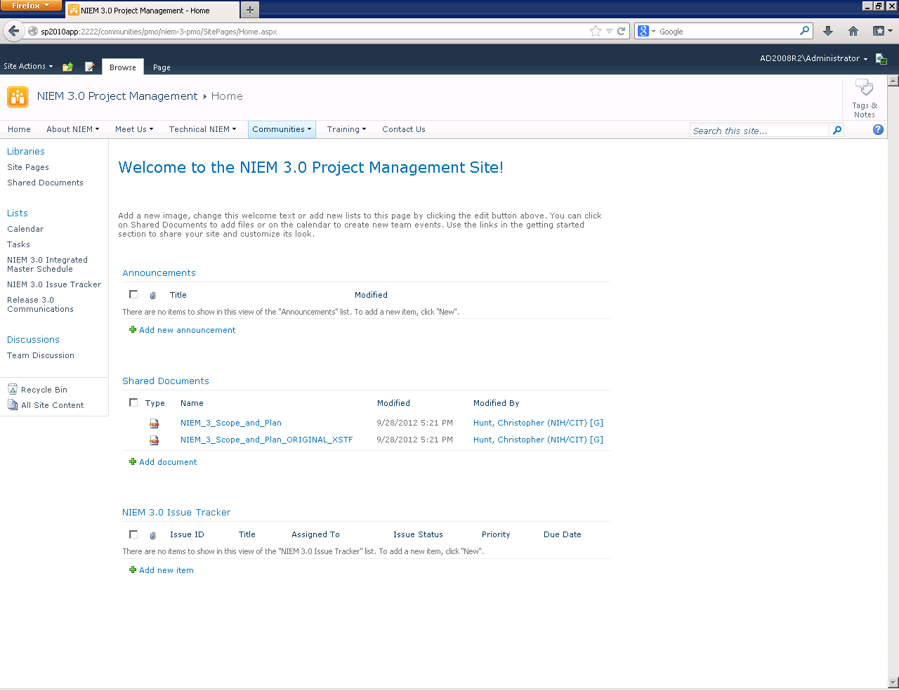

Select **Page** tab in the ribbon and then select the **Edit** icon in the ribbon.

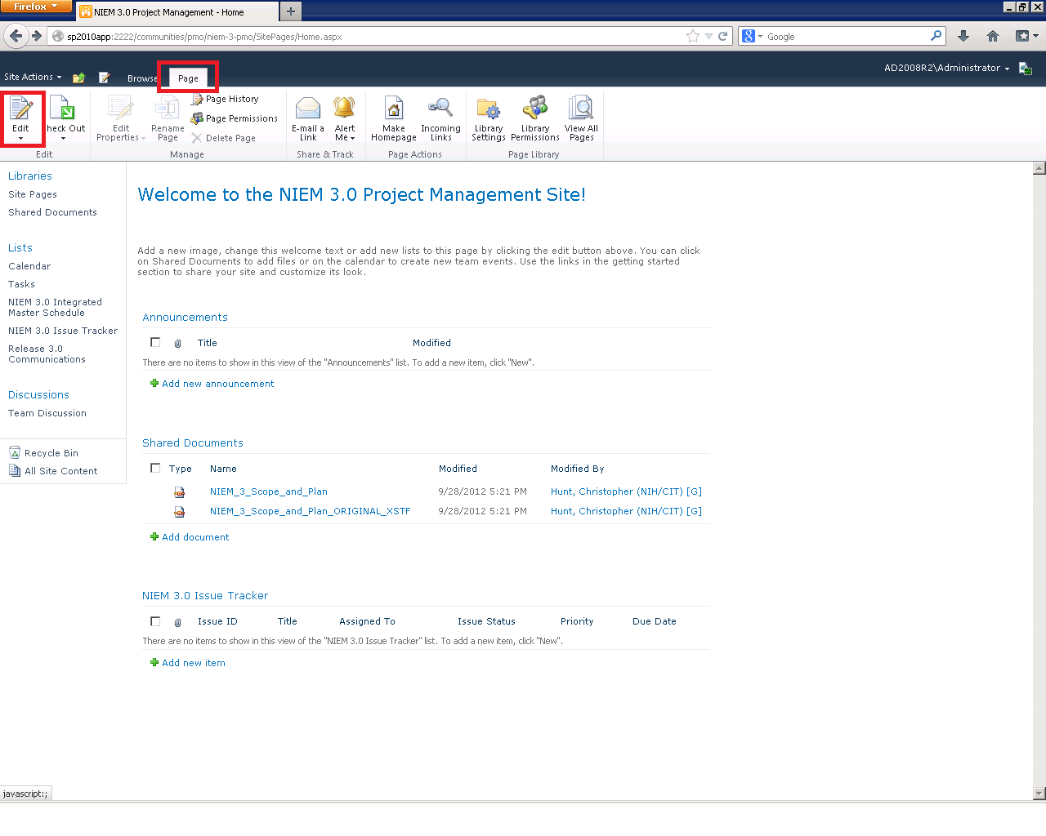

Place your cursor in the page where you would like to place the Bamboo calendar. Then, select the **Insert** tab in the ribbon and then select the **Web Part** icon.

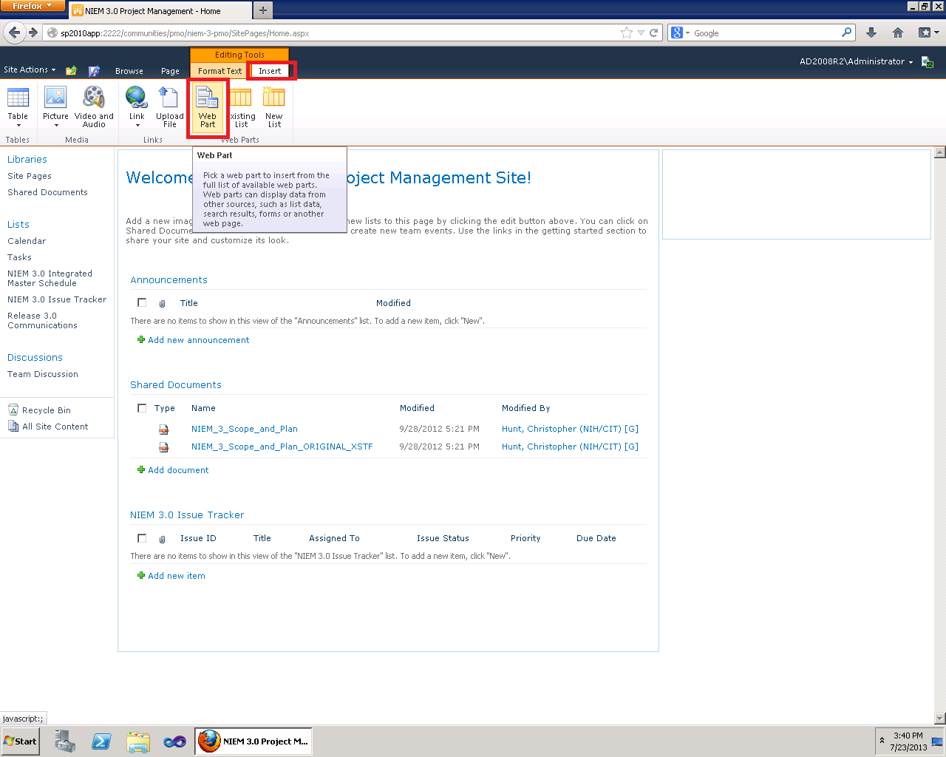

The ribbon will expand so that you can select the web part you wish to insert. Select the **Bamboo Solutions** category and select **Bamboo Calendar Plus Web Part**. Then, click on the **Add** button to insert the web part into the page where your cursor was positioned.

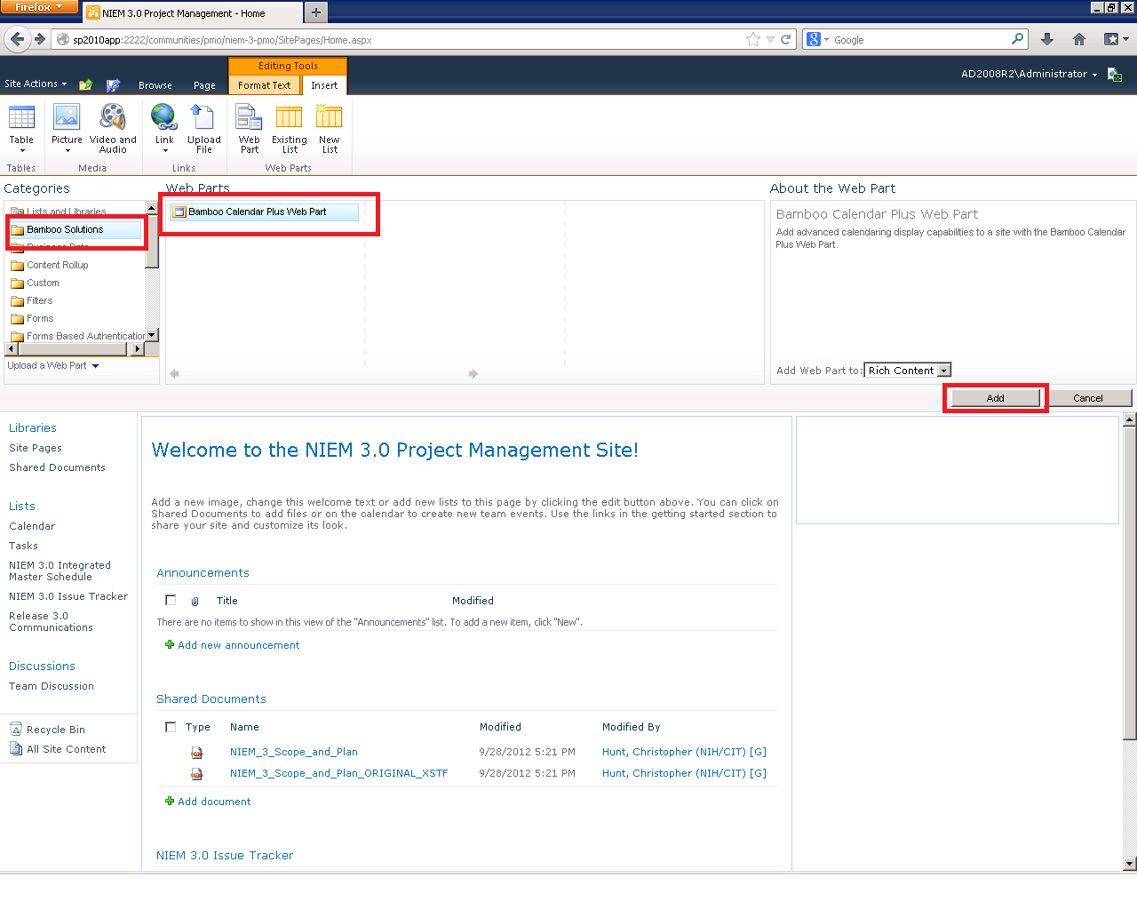

<https://www.niem.gov/communities/cross-domain/Pages/Cross-Domain.aspx>

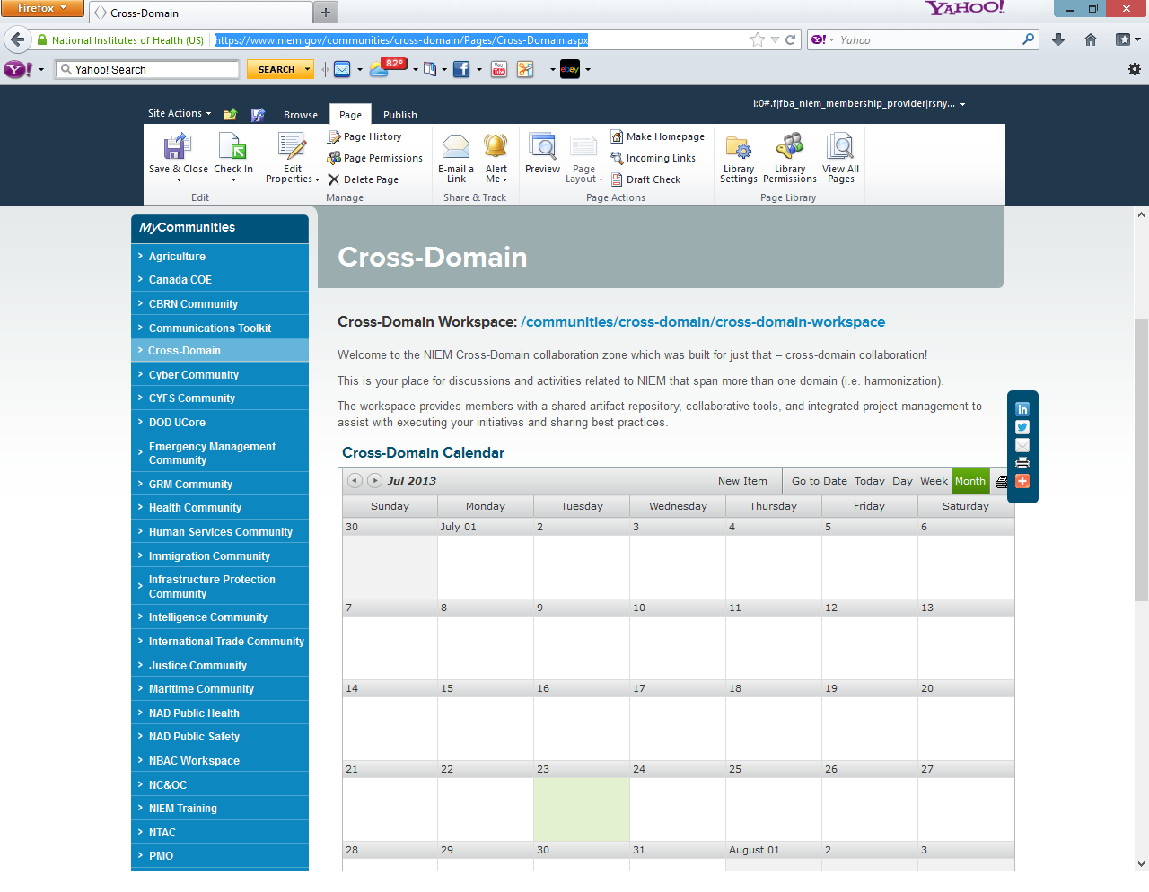

Next, edit the web part and expand the **Calendar Plus Settings** group in the web part properties pane. Click on the **Calendar Plus Web Part Settings** button.

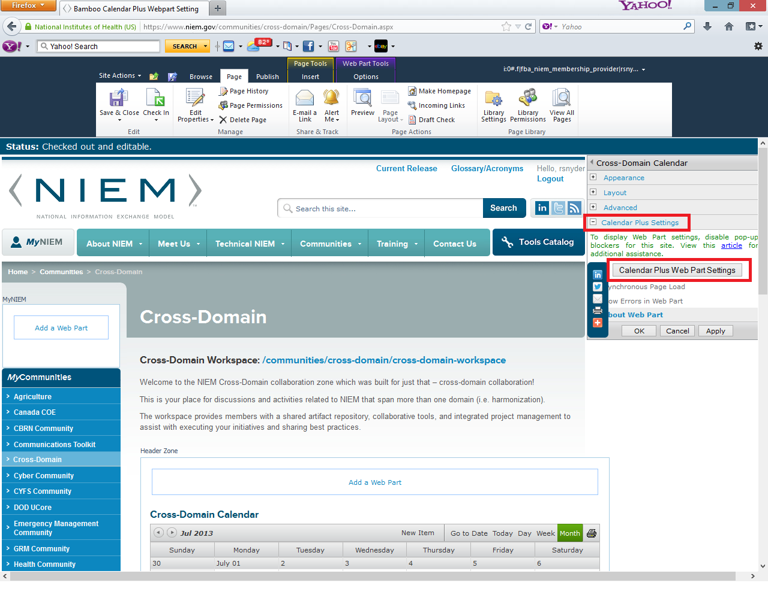

Click on **SharePoint List and Library** button in the left hand pane and the right hand pane will refresh to show the lists and libraries being displayed in the calendar web part. To add another list, click on the **Add List or Library** button.

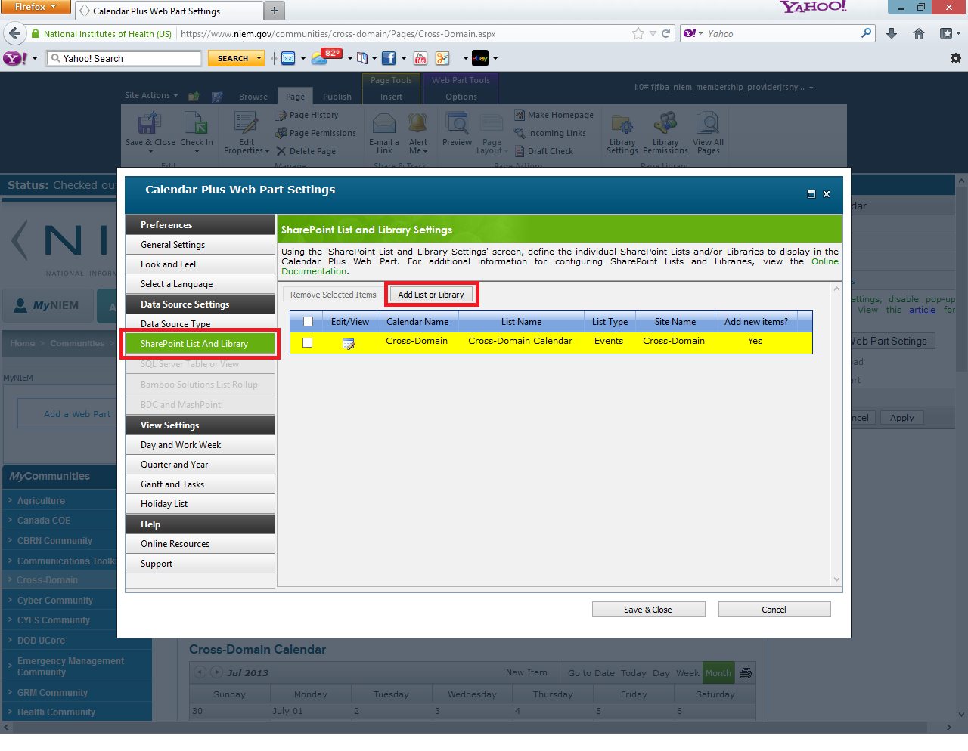

The next screen will contain several required steps and some optional steps. So, this is showing the answer for step 1 where you provide the calendar name and select a color.

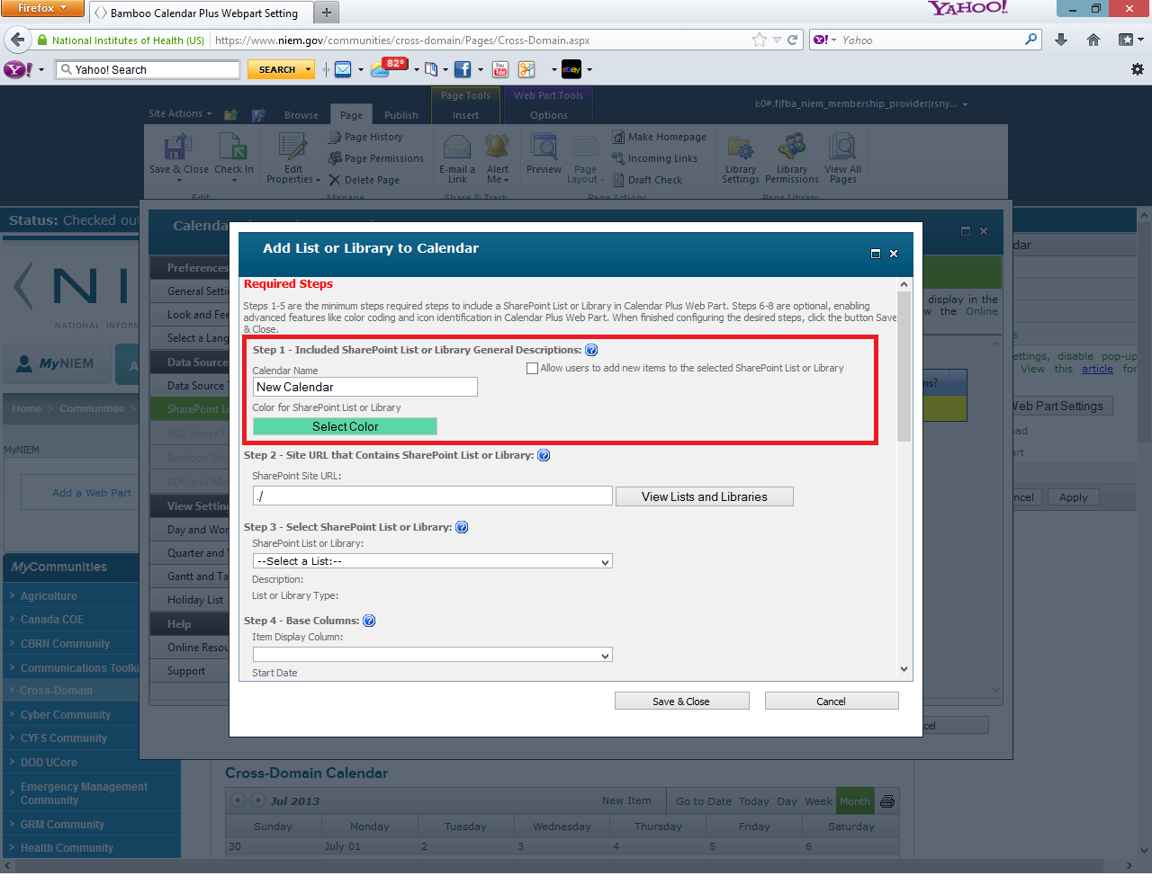

For step 2 we need to provide the url to the **site** that contains the list or library we will include in the calendar. The **View Lists and Libraries** button does not open a browse window. This button refreshes the contents of the drop downs in later steps. This image shows the selection of a child site beneath the /communities/cross-domain site. The important thing to note is this entry is a relative site url that you must type in. So, you do not need to include the server name of <https://www.niem.gov>. You can enter in one of two values for this url. You can use /communities/cross-domain/Cross-Domain-Workspace or you enter in the relative url based on the site where the web part is located so you would type in ./Cross-Domain-Workspace for a child site. Click on the **View Lists and Libraries** button once you enter in the url.

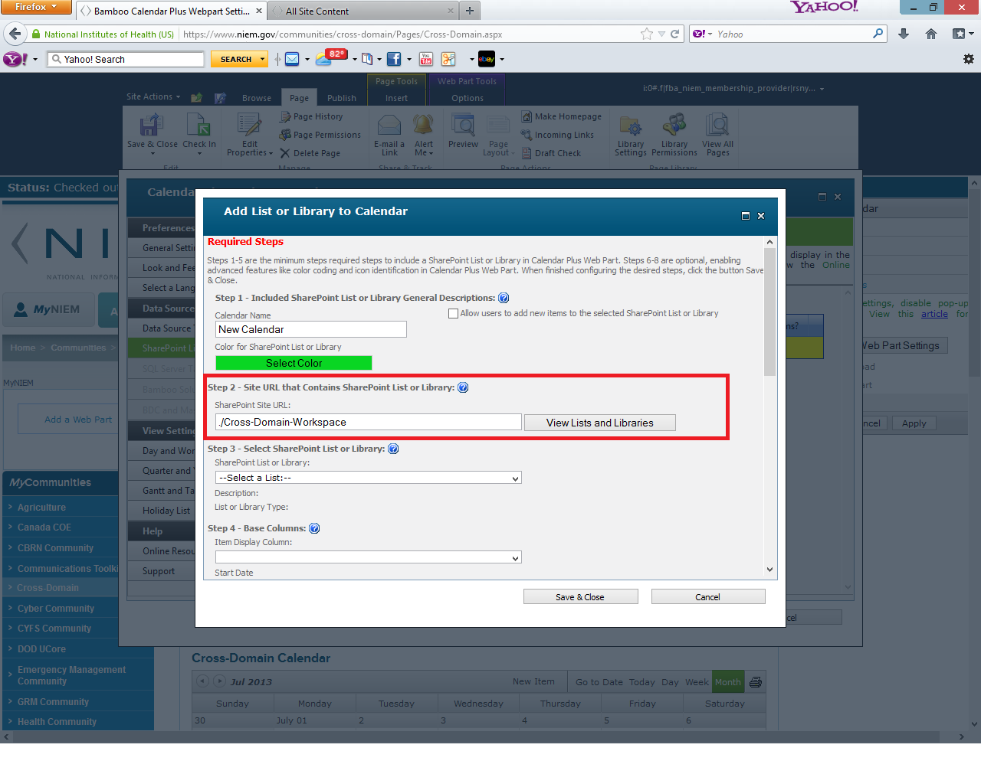

Next, you select the calendar in the drop down to show in the web part

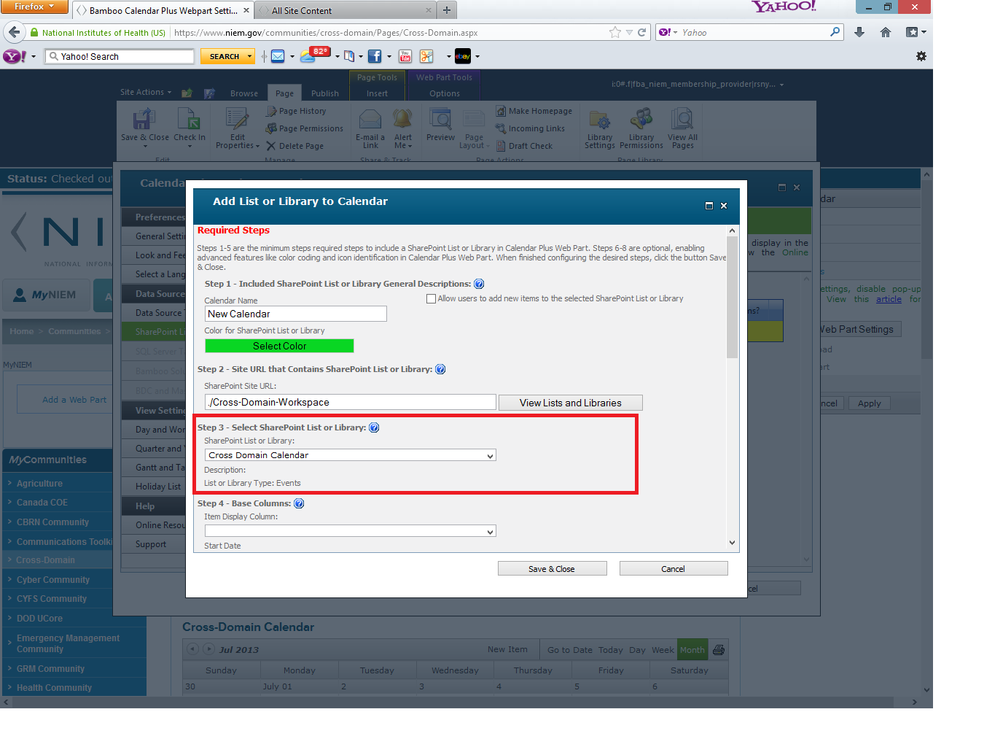

In step 4, you need to select the fields to show in the web part. The Title is a good choice for the **Item Display Column**. The start

